**About the Dataset**

The dataset contains the data related to Geography Wise Per Capita Gross National income of Nepal for the Year 2014. The geographical observations are categorized according to Districts, zones, geographical regions, demographic regions and various sub categories of per capital gross national income (Sectors of the economy). The wrangling and visualization analysis of the data are performed on the basis of multiple facets mentioned above.

**Note**

The missing values N/A values in the dataset have been replaced with null values (i.e replaced with value zero). Therefore, the districts that appear as blank on the map of Nepal are the result of the unavailability of data for those particular districts.

**Objective:**

1. To understand the economic composition of Nepal
2. To assess the high growth economic sectors of Nepal

**Research question**

What are the economic sectors that add the highest and lowest value across the economy of the development regions of Nepal?

1. **The dashboard**

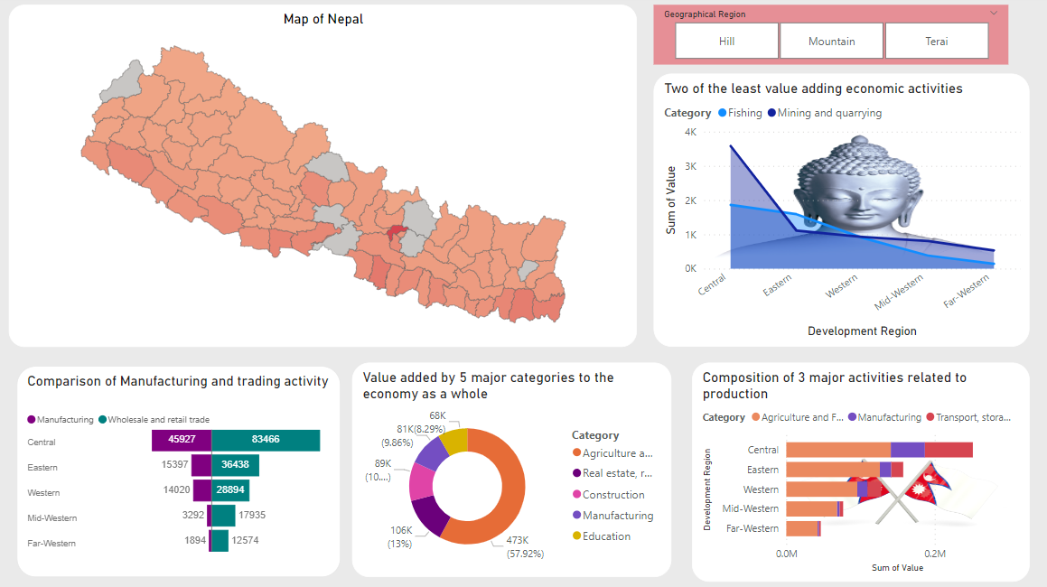

1. **Map of Nepal**

The map of Nepal has been shaped with the help of a json file. The map is divided into 75 districts where the color gradient is fixed in such a way that the districts with lower value addition to the economy appear light reddish and the districts with higher value addition to the economy appear dark red in color. The map itself acts as a slicer when we click on it. Without even clicking, we can identify Kathmandu as the most value adding district by its dark red color.

1. 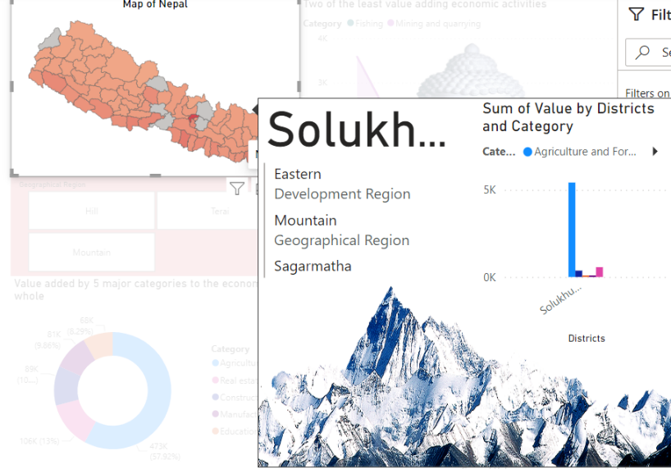**Slicer and tooltip**

A separate slicer is used where the data visuals are sliced according to the geographical regions of Nepal. The three geographical region’s info will be highlighted in the videos respectively if the slicer tiles are clicked. Also, a tooltip has been developed for providing the summary information about the economic activities of the respective district. The tooltip would be displayed as shown in the adjacent picture.

1. **Value added by 5 major categories to the economy of development regions**

Agriculture, Real estate, Manufacturing, Education and Construction are the 5 most valuable sectors of Nepalese economy. If we look at the categories that add the most value to the economic activity across the development regions, Agriculture is the activity that adds the highest value in all the development regions. Central development receives the highest contribution from agriculture. On the other hand, Manufacturing is almost non existent in case of mid western and far western development regions. A clustered bar chart is used to show the details.

1. **Two of the least value adding economic activities**

Fishing and Mining and quarrying are the two least contributing economic activities across all the five development regions. The mining and quarrying is high in the central development region especially in Kathmandu whereas the actual potential of mining and quarrying activity lies outside of central development region. Also, central development region ranks the highest in Fishing activity whereas the real potentiality of fishing activity is in the flat lands of western and eastern development regions.

1. **Comparison of Manufacturing and trading activity**

This particular visual is aimed at depicting the difference between the value addition from Manufacturing and trading activity across the development regions of Nepal. Nepal has always been an import dependent nation. We have often heard that the key for economic growth is to accelerate the Manufacturing activity of the country. We can clearly observe that the size of trading is twice the size of manufacturing in the central development region which shows how dependent we are on import. Moreover, the manufacturing activity is almost nonexistent in Mid western and far western development regions.

1. **Composition of three major economic activities related to production across the development regions**

We have already discussed about the importance of manufacturing as an economic activity in an economy. There’s no doubt that agriculture, the backward link of the industries is the most value adding economic sector across all the development regions. However, we can clearly see how Transportation and storage has completely outsized the Manufacturing activity of the country. In fact, the manufacturing activity should completely outsize the transportation and storage activity in order to make the country a self-sufficient nation.

1. **Value added by 5 major categories to the Nepalese economy as a whole**

This particular visual is aimed at providing a summary of the most important economic sectors of the country. Agriculture, real estate, construction, manufacturing and education are the most value adding sectors or activities to the Nepalese economy. It is very clear that Agriculture is the most important economic sector of the country. Whereas, manufacturing and education are the least value adding among the top five. Moreover, manufacturing sector is the one that is seriously lagging behind. It should be right up there with the agriculture sector to provide us with a considerable private sector led economic growth

1. **Additional visuals**

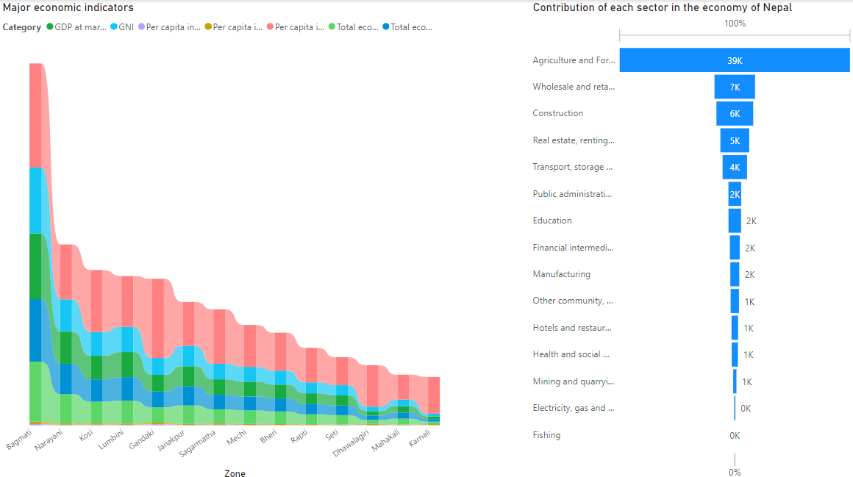

The visual on the left is aimed at depicting the major macroeconomic indicators across some selected districts. We can clearly see how Bagmati zone dominates all the major economic indicators through the help of a ribbon chart.

Similarly, the visual on the right displays the contribution of all the sectors in the economy of the country. Agriculture and forestry is the most value adding sector. Whereas, industries like Mining and quarrying, electricity and water and fishing are really lagging behind even though there is immense potential for these particular sectors.

**References**

[**https://data.opennepal.net/datasets?field_dataset_sector_tid%5B0%5D=148&page=1**](https://data.opennepal.net/datasets?field_dataset_sector_tid%5B0%5D=148&page=1)